I do not have a clue how to answer this question.

4) Fill in the molecules represented by the letters below.
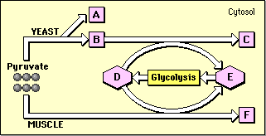
A)
B) Acetaldehyde
C)
D)
E)
F)

